**Connecting a Database in ASP.NET**

To create a new database using the administration-free implementation of LocalDB, start by opening the Server Explorer window from the View menu. At the top will be an icon that looks like a cylinder with a plug next to it. Click that icon to connect to a database.

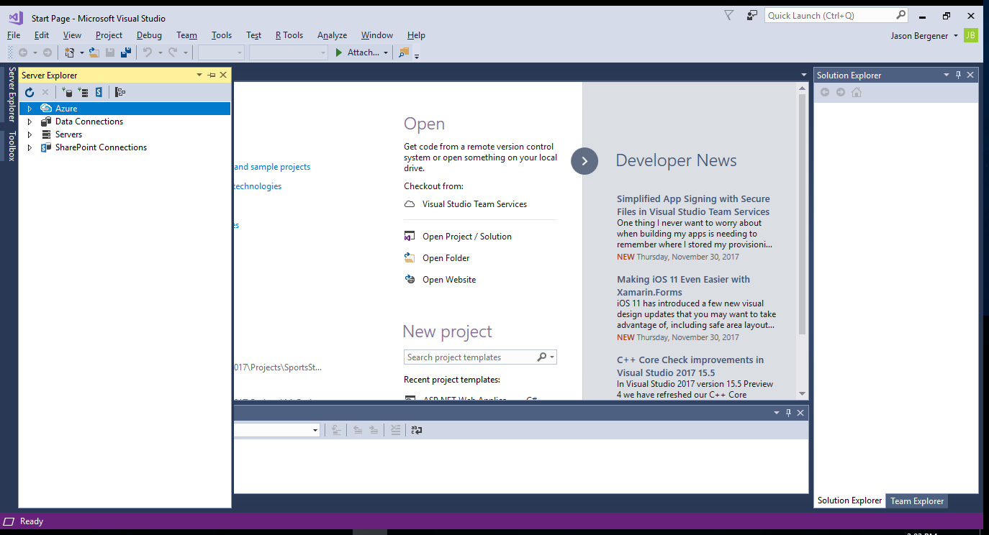

In the Choose Data Source window that pops up, choose Microsoft SQL Server. In the Add Connection box, for Server name, input “(LocalDb)\MSSQLLocalDB” without the quotes. Then select or enter a database name and click OK. You have successfully connected a database to your app.

If (LocalDb)\MSSQLLocalDB doesn’t work for you (usually because you’re using a newer implementation) you can figure out the correct connection screen by building a new MVC app and choosing Individual User Accounts for Authentication. This will build a database connection for you so you can look in the project’s Web.config file and see what the correct connection string looks like for your version.

To connect a remote database, you simply put the remote server’s information in for the Server name in the Add Connection box.

If you want to use Microsoft SQL Server Management Studio to open a database file (like the mdf files that are created with ASP.NET) you need to ensure that SSMS has access to the files. If you just want to work with a copy of the data, it is easiest just to copy the files to a directory that SSMS can access; for example: C:\Program Files\Microsoft SQL Server\MSSQL13.SQLEXPRESS\MSSQL\DATA. If you want to manage the database while still using it in the project, you will need to adjust the security settings for your folders to allow SSMS to access them.